### India’s Agricultural Crop Production Analysis

### (1997-2021)

**Introduction:**

This report delves into the captivating realm of India's agricultural cultivation, providing a comprehensive visual exploration of key aspects and trends in the agricultural sector. Through the visual representations, readers can gain valuable insights into crop production, seasonal variations, regional distribution, and overall production trends. These visualizations enable intuitive analysis, allowing stakeholders to uncover patterns, identify areas of growth or concern, and make data-driven decisions.

**Purpose:**

This report not only presents the data in a visually appealing manner but also provides an interactive experience for readers to explore the intricacies of India's agricultural cultivation. To Extract the Insights from the data and put the data in the form of visualizations, Dashboards and Story we employed Tableau tool.

**Conclusion & Future Scope**

Agriculture serves as a vital source of livelihood for a large portion of the population, especially in rural areas. It plays a crucial role in ensuring food security and alleviating poverty by providing employment opportunities and income generation. Moreover, agricultural activities contribute to the overall socio-economic development of rural communities, fostering social cohesion and preserving cultural traditions.

From a business perspective, the agricultural sector plays a pivotal role in India's economy. It contributes to the country's GDP and serves as a source of raw materials for various industries, such as food processing, textile, and pharmaceuticals. The growth and productivity of the agricultural sector have direct implications for the overall economic performance and stability of the nation. Furthermore, advancements in agricultural practices and technology have the potential to enhance productivity, optimize resource utilization, and promote sustainable practices. This, in turn, can lead to increased profitability and competitiveness for agricultural businesses.

**Screenshot of Brainstorming Map**

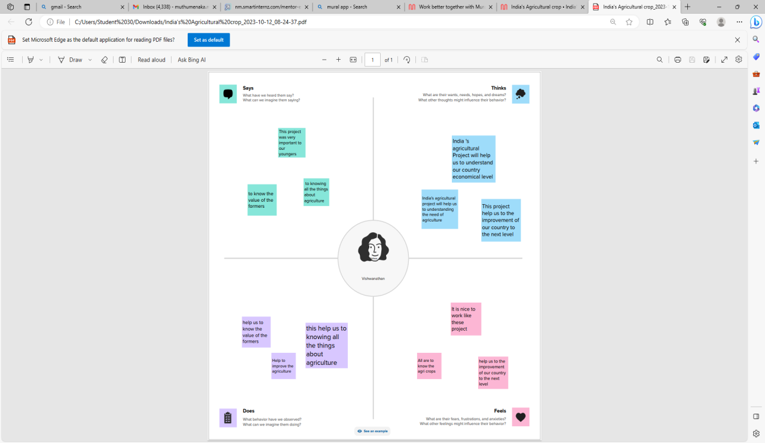

**Screenshot of Empathy Map**

